**Lab – 14**

create database Lab14;

use Lab14;

DELIMITER //

CREATE PROCEDURE FindGreatest(IN A INT, IN B INT, IN C INT)

BEGIN

IF A > B AND A > C THEN

SELECT CONCAT('A is the greatest: ', A) AS Result;

ELSEIF B > C THEN

SELECT CONCAT('B is the greatest: ', B) AS Result;

ELSE

SELECT CONCAT('C is the greatest: ', C) AS Result;

END IF;

END;

//

DELIMITER ;

CALL FindGreatest(10, 20, 15);

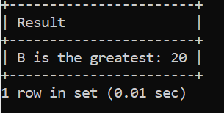

DELIMITER //

CREATE PROCEDURE DisplayMessage()

BEGIN

DECLARE i INT DEFAULT 1;

WHILE i <= 20 DO

SELECT 'Welcome to PL/SQL Programming' AS Message;

SET i = i + 1;

END WHILE;

END;

//

DELIMITER ;

CALL DisplayMessage();

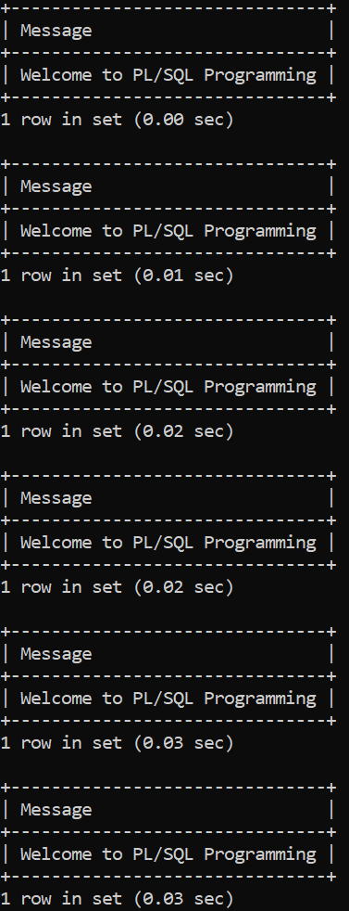

DELIMITER //

CREATE FUNCTION FindFactorial(N INT) RETURNS INT

BEGIN

DECLARE Factorial INT DEFAULT 1;

DECLARE i INT DEFAULT 1;

WHILE i <= N DO

SET Factorial = Factorial * i;

SET i = i + 1;

END WHILE;

RETURN Factorial;

END;

//

DELIMITER ;

SELECT FindFactorial(5) AS Factorial;

DELIMITER //

CREATE PROCEDURE GenerateFibonacci(IN N INT)

BEGIN

DECLARE a INT DEFAULT 0;

DECLARE b INT DEFAULT 1;

DECLARE c INT;

DECLARE i INT DEFAULT 3;

SELECT a AS FibonacciSeries UNION ALL

SELECT b;

WHILE i <= N DO

SET c = a + b;

SELECT c;

SET a = b;

SET b = c;

SET i = i + 1;

END WHILE;

END;

//

DELIMITER ;

CALL GenerateFibonacci(10);

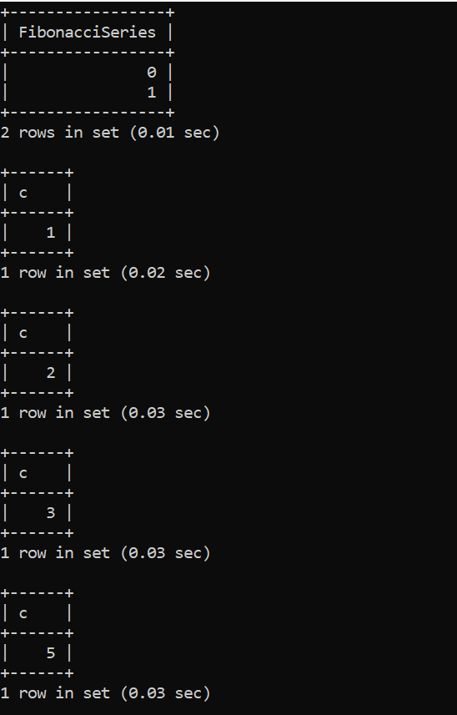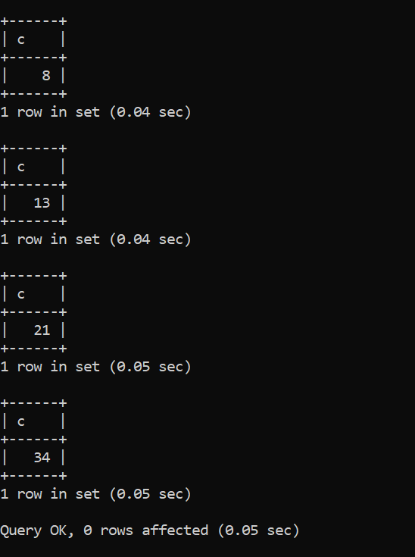

DELIMITER //

CREATE FUNCTION SumOfN(N INT) RETURNS INT

DETERMINISTIC

BEGIN

DECLARE Total INT DEFAULT 0;

DECLARE i INT DEFAULT 1;

WHILE i <= N DO

SET Total = Total + i;

SET i = i + 1;

END WHILE;

RETURN Total;

END;

//

DELIMITER ;

SELECT SumOfN(10) AS Sum;

